EPISODIC MEMORY

Baseline: Pi's Current Episodic Memory
The current Pi architecture compresses completed execution trajectories, indexes them in an episodic vector store, and retrieves similar past trajectories through the context hook. This provides recall of previous problem-solving experiences, but it does not explicitly distinguish successful from failed strategies, align memories with the agent's current subtask, or iteratively verify whether retrieved memories are sufficient for the current decision.

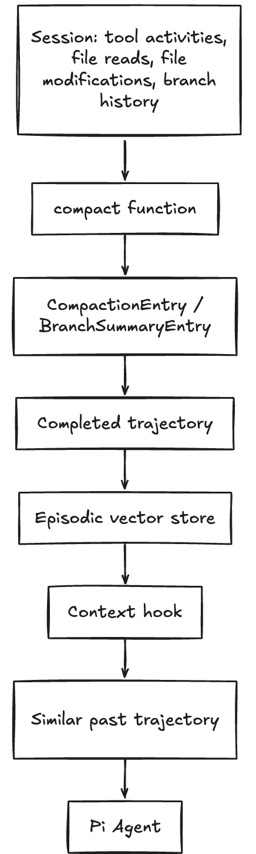

Baseline representation: Trajectory = <Goal, Hypotheses, ToolSequence, RootCause, ResolutionPatch>

Architecture 1 — Contrastive Episodic Memory

A. Core Concept & Formulation
Instead of storing only a trajectory, represent an episode as a contrastive experience containing the problem state, failed strategy, successful strategy, outcomes, divergence point, and resulting lesson.
ContrastiveEpisode = <Goal, InitialState, FailedTrajectory, FailedOutcome, SuccessfulTrajectory, SuccessfulOutcome, DivergencePoint, Lesson>
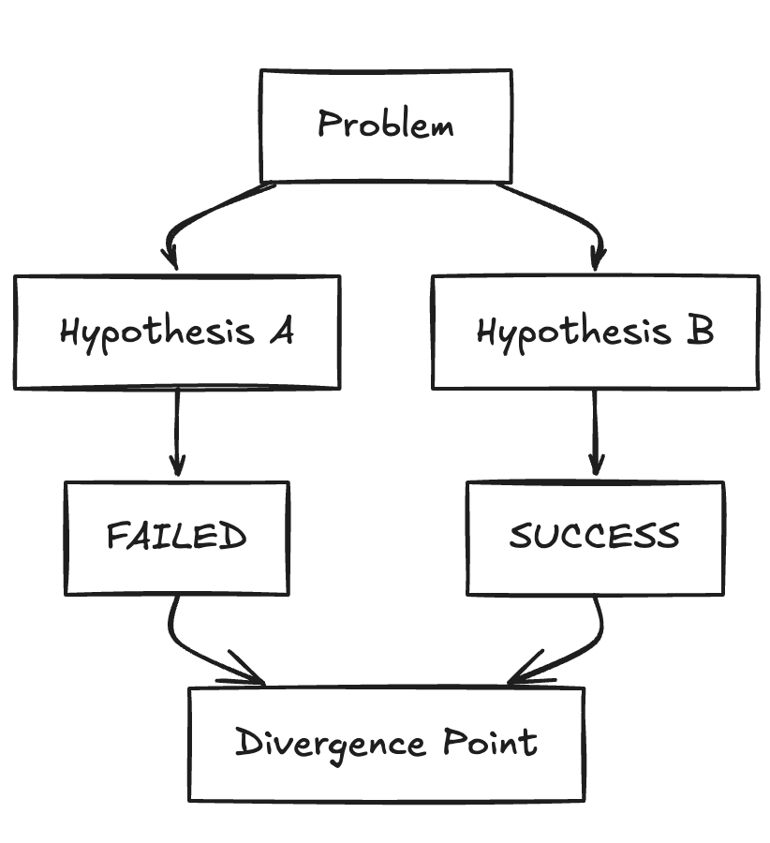
Proposed memory schema
interface ContrastiveEpisode {
problemSignature: string;
initialState: StateSnapshot;
failedTrajectory: {
hypothesis: string;
actions: Action[];
observations: Observation[];
failure: FailureEvidence;
};
- successfulTrajectory: {
hypothesis: string;
actions: Action[];
observations: Observation[];
outcome: SuccessEvidence;
};
divergencePoint: {
step: number;
decision: string;
};
lesson: string;
verification: {
testsPassed: number;
testsFailed: number;
evidence: string[];
};
}
B. Pi Agent Subsystem Integration
- Active Task Failure: Pi attempts a solution (e.g., modifying tsconfig.json to fix an ESM import error). The test command fails with an unhandled module resolution exception.
- Backtrack & Fork: The agent backtracks to step k in the session tree (commonAncestorId) and tries an alternative hypothesis (e.g., adding an explicit extension mapping in package.json).
- Verification & Success: The alternative branch runs npm test, achieving testsPassed: 42, testsFailed: 0.
- Asynchronous Consolidation: Upon sessionSettled, harvestContrastiveEpisode() collects the aborted branch and the succeeding branch, computes divergencePoint, synthesizes the lesson, and persists the ContrastiveEpisode into SQLite.
- Next Session Pre-Flight Interception: In a future session with a similar problemSignature:The context hook injects the lesson and divergencePoint into the system prompt.If the agent nonetheless tries to repeat the old mistake, beforeToolCall catches the command before dispatch and injects an immediate mitigation prompt.
C. Impact Over Baseline
- Explicitly stores negative trajectories (τ-) and uses beforeToolCall to actively intercept known trap actions before OS dispatch.
- Isolates the exact Causal Pivot Delta (Δpivot) through counterfactual diffing, providing the model with the exact inflection point that changed the test from red to green.

D. Research Papers : Reflexion (Shinn et al.)

Architecture 2 — Structurally Aligned Subtask Milestone DAG (STAIR / Subtask-Memory)
A. Core Concept & Mathematical Formulation
Rather than compressing an entire multi-hour problem-solving session into a monolithic record ⟨Goal, Hypotheses, ToolSequence, RootCause, ResolutionPatch⟩, this architecture decomposes the trajectory into a Hierarchical Subtask Milestone DAG:
Formal Representation: M_{DAG} = (S, E_{dep}), where S = { s_repro, s_local, s_hypo, s_synth, s_valid }
Each milestone node si ∈ S represents a functional software engineering phase governed by explicit pre- and post-condition contracts:
1. Issue Reproduction (s_repro): Isolated test script or harness that triggers the reported symptom deterministically (precondition: raw user issue → postcondition: reproducing test exit code ≠ 0).
2. Fault Localization (s_local): AST symbols and file ranges identified as root-cause locations (precondition: reproducing test → postcondition: bounded candidate AST nodes).
3. Causal Hypothesis (s_hypo): Mechanistic explanation of the state mismatch.
4. Patch Synthesis (s_synth): Parameterized code transformation template applied to the localized AST.
5. Regression Verification (s_valid): Full repository test suite assertion (postcondition: exit code 0 with zero regressions).

interface SubtaskMilestoneNode {
subtaskId: string;
sessionId: string;
phaseType: "reproduction" | "localization" | "hypothesis" | "synthesis" | "verification";
subgoal: string;
preconditions: { diagnosticRegex?: string; activeASTSymbols?: string[] };
minimalActionSequence: Array<{ tool: string; args: Record }>;
postconditions: { verifiedExitCode: number; stateAssertionsMet: boolean };
touchedFiles: string[];
dependencyIds: string[]; // Edges in E_dep
}

B. Pi Agent Subsystem Integration
1. Subtask-Aware Compaction Engine (compaction.ts ): Pi’s current compact() function in packages/coding-agent/src/core/compaction/compaction.ts compiles history into an undifferentiated CompactionEntry. This architecture replaces coarse compaction with a State Machine Milestone Compiler. As the agent navigates from test exploration to code modification, the compiler detects phase boundaries via extractFileOperations and serializes discrete SubtaskMilestoneNode entries.
2. Granular Phase-Matched Retrieval (core/context.ts ): When Pi executes a turn, the prompt builder inspects the agent's active sub-goal. Instead of injecting a full-session 2,000-token trajectory, it queries the subtask index using a targeted composite metric: Score(s, q) = 0.50 · Sim(v_subgoal, v_q) + 0.30 · AST Overlap(s.symbols, q.symbols) + 0.20 · PhaseMatch(s.phase, q.phase). The system injects an ultra-dense ≤ 120-token milestone recipe matching only the current phase.
3. Plan-Memory Coupling (agent-loop.ts ): The active execution plan in Pi is synchronized with the milestone graph, ensuring that subsequent subtasks inherit valid state assertions from preceding milestones.

C. Impact Over Baseline

- Surgically injects only the active phase milestone (≤ 120 tokens), preserving 90%+ of context window for active code analysis
- Stores abstract AST transformations and semantic preconditions rather than frozen diffs, allowing dynamic adaptation to refactored code.

D. Research Papers

Dong, Y., et al. (2026). Structurally Aligned Subtask-Level Memory for Software Engineering Agents

Zhang, C., et al. (2026). Coupling Planning with Episodic Memory in LLM Agents for Software Issue Resolution

Architecture 3 — Closed-Loop Episodic Retrieval
Research basis: MemR³ frames retrieval as a closed-loop process in which an agent can retrieve, reflect, refine the query, and continue retrieval rather than relying on a single retrieval pass. For Pi, the most natural adaptation is Retrieve → Assess → Apply/Reason → Verify → Refine → Retrieve.

A. Core Concept & Formulation

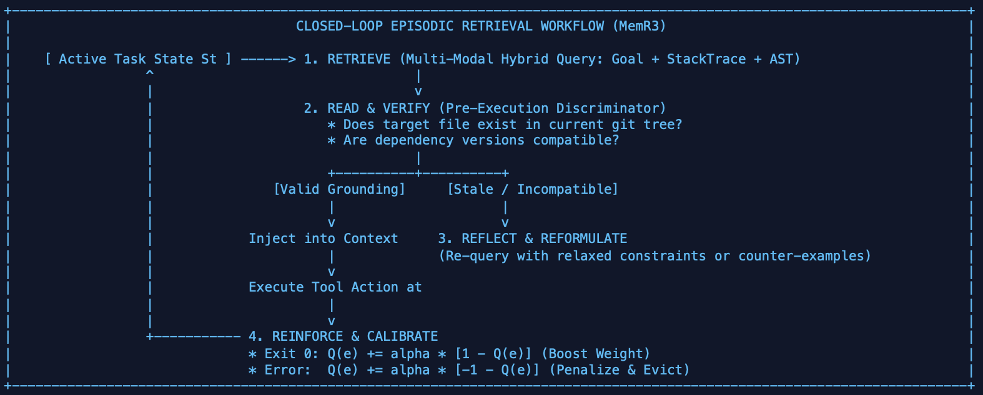

B. Pi Agent Subsystem Integration
1. Execution Feedback Sentinel in agent-loop.ts : Binds to both beforeToolCall and afterToolCall in Pi's execution loop. When memory is injected into turn t, the Sentinel monitors tool result Ot. If Ot is an error or exception, the Sentinel flags the memory as discordant and triggers immediate re-retrieval with error diagnostic context.
2. Workspace Grounding Validator (core/context.ts ): Extends Pi's context assembly. Candidate episodes pass through a fast local filesystem validator. If an episode references src/legacy/auth.ts which no longer exists in the git index, the record is flagged for re-grounding and withheld from prompt context.
3. Self-Evolving Store (.pi/memory/episodic.db ): SQLite table augmented with access counters, success rates, and Q-values. Low-utility records with Q(e) < -0.4 are automatically evicted during periodic database compaction.

C. Impact Over Baseline
- Pre-execution discriminator verifies symbols against the active workspace AST before prompt injection, eliminating grounded hallucinations.
- Closed-loop TD learning (Q-updates) dynamically suppresses failed memories (R= -1.0) and promotes winning strategies, creating a self-improving memory store.

D. Research Papers : MemR3: Memory Retrieval via Reflective Reasoning for LLM Agents
CASUAL MEMORY

Baseline: Current Pi Causal Memory
The current architecture is treated as the experimental baseline. A past failure is converted into a flat causal rule containing a condition, action, outcome, mechanism, and mitigation. During execution, the rule is checked in the beforeToolCall hook. If the planned action matches a known failure condition, Pi blocks execution and injects the causal explanation back into the model context.

Past failure
↓
CausalRule
{condition, action, outcome, mechanism, mitigation}
↓
beforeToolCall
↓
Rule matching
↓
ALLOW or BLOCK + explanation

Architecture 1: Causal Dependency Graph Memory

A. Core Concept & Formulation
Instead of viewing memory as isolated chunks of text or independent JSON rules, Causal Dependency Graph Memory models the entire agent-workspace interaction as a dynamic ttyped Directed Causal Graph:

$G=(V,E,Φ,Ψ)$

- Nodes ($V$): Typed entities comprising Code Artifacts (source files, AST symbols, configuration manifests), Runtime Resources (daemon processes, bound ports, active fixtures), Interventions ($do(toolCall)$), and outc omes (exit codes, test traces).
- Edges ($E$): Typed directed causal relationships: DEPENDS, ON, MUTATES, STATE,REQUIRES, PRECONDITION, INVALIDATES, and PRODUCES SIDE EFFECT.
- Memory Reconstruction over Static Retrieval (MRAgent Paradigm): Human memory does not retrieve
static text, it reconstructs relational subgraphs tailored to the active cue. When Pi initiates a task, rather than querying a flat vector DB, it formulates retrieval as a Prize-Collecting Steiner Tree. It extracts the minimal connected causal subgraph linking the user's objective, the target files, and historical prerequisite invariants.

B. Pi Agent Subsystem Integration

1. Hook Placement in packages/agent/src/agent-loop.ts

- afterToolCall Hook (State Diff & Lineage Ingestion): Upon tool execution completion, an AST diff parser inspects stdout, modified files, and process states, writing causal nodes and dependency edges into an in- memory Graphology graph backed by SQLite (.pi/memory/causal_graph.db).
- contextAssembly / System Prompt Hook: Before LLM generation begins, G-Retriever runs a personalized PageRank/PCST seeded by the user goal and modified files, injecting a structured, high-density causal subgraph into system context

2. Storage Architecture: SQLite graph schema with an in-memory bidirectional adjacency index, guaranteeing sub-millisecond path traversal during the agent loop.

Impact Over Baseline

- Multi-Hop Cascading Error Resolution: The baseline evaluates Turn 8 (running pytest) in complete isolation.The Causal Dependency Graph traces the dependency lineage back to Turn 3 (editing the fixture), immediately informing the agent of the root causal mechanism.
- Context Window Efficiency (Subgraph Pruning): Reduces prompt bloat by over 70%. Instead of dumping raw execution logs into the prompt, Pi injects only the minimal connected causal Steiner subgraph relevant to the current decision.
- Elimination of Stale Knowledge Execution: Prevents the agent from falsely assuming that past successes or green test runs still hold true after code modifications.
Research Papers
- Memory is Reconstructed, Not Retrieved: Graph Memory for LLM Agents (MRAgent) — Ji, Li & Ho, 2026
- Graph-Based Personalized Memory for LLM Agents: Representation, Evolution, Retrieval, and Evaluation — Nguyen et al., 2026
- G-Retriever: Retrieval-Augmented Generation for Textual Graph Understanding and Question Answering — He et al., 2024

Architecture 2 - Intervention-Based + Counterfactual Causal

A. Core Concept & Formulation
Combine observed intervention memory with counterfactual reasoning. Instead of storing only action A caused failure,store the state in which an action was actually performed, the observed outcome, alternative interventions, and the outcomes associated with those alternatives.

State S
do(Action A) → Failure
do(Action B) → Success
do(Action C) → Unknown

Counterfactual:
Under the same state S, what would likely have happened if B had been chosen instead of A?

The intervention perspective can be framed as estimating the effect of an action under a state, conceptually P(Y | do(A), S). The counterfactual extension asks about the outcome under an alternative action while holding the relevant state fixed.

Research grounding: ActMem is directly relevant because it combines actionable memory with causal/semantic
structures and counterfactual reasoning. Causal-inference literature provides the conceptual distinction between
observation, intervention, and counterfactual reasoning. Memory-consolidation research is relevant to deciding which experiences should be retained or abstracted.

B. Pi Agent Subsystem Integration

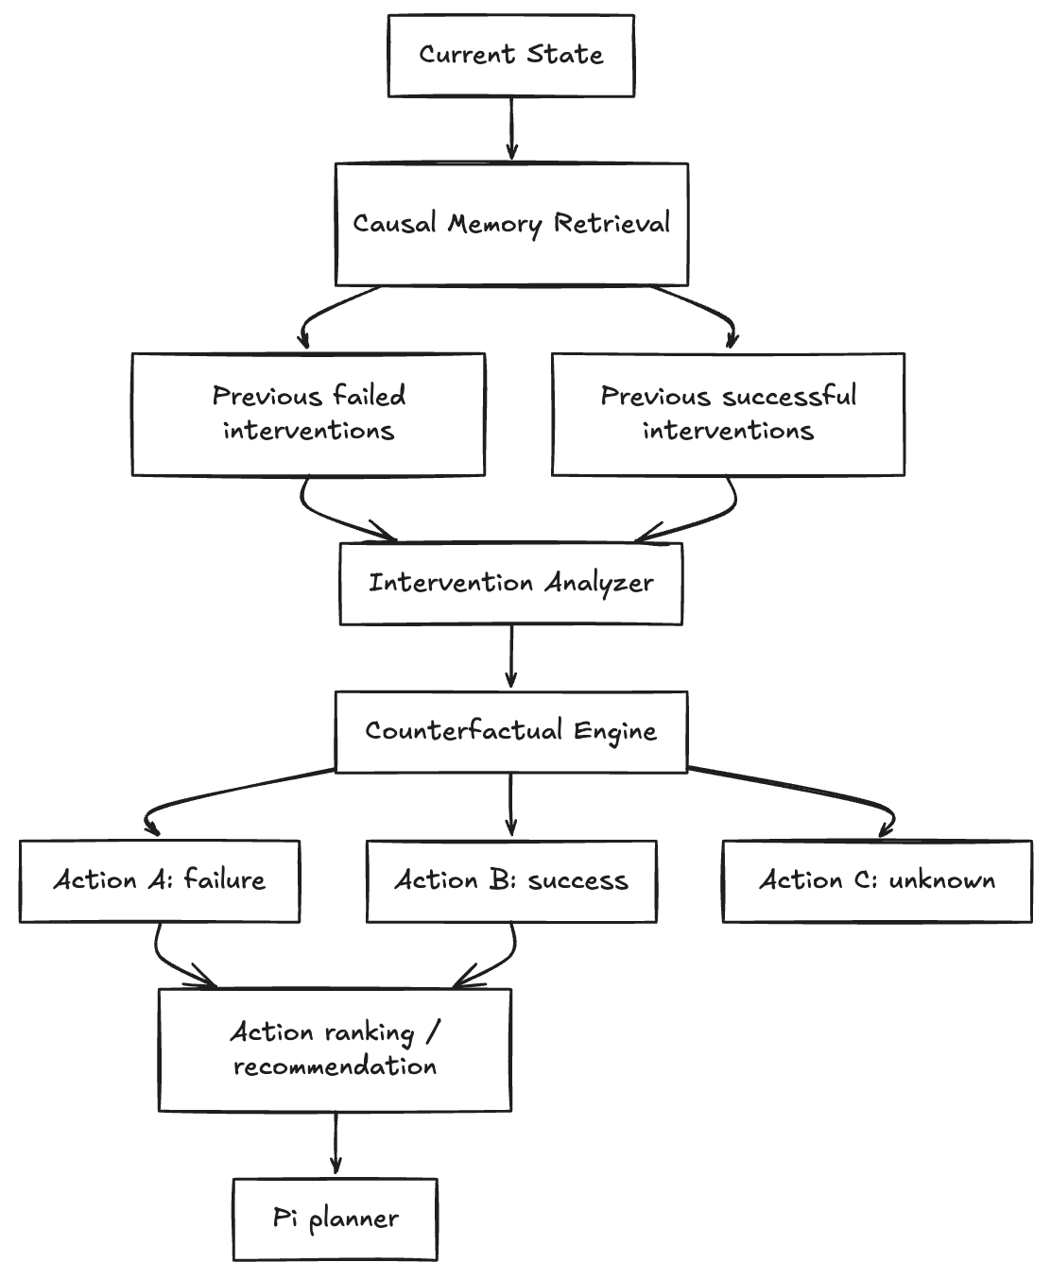

- beforeToolCall: identify the current state, retrieve previous interventions, compare observed outcomes, and provide an alternative-action recommendation.
- afterToolCall: record the state, action, observed outcome, and relevant alternative actions.
- Memory entry: preserve provenance, task context, environment, observed outcome, and confidence/evidence for each intervention.
- Decision behavior: move from simple blocking toward recommendation of an action that has historically produced a better outcome under comparable conditions
C. Impact Over Baseline
- Compare multiple actions and their consequences
- Proactive action selection

D. Research Papers
- ActMem: Actionable Memory for LLM Agents — 2026
- The Epistemics of Agent Memory: Measuring, and Governing, the Consolidation Decision in
- Long-Horizon LLM Agents — Annapureddy & Thamatani, 2026
- Causal Reasoning and Counterfactual Inference: A Survey (relevant causal-inference foundation)
- From Reasoning to Agentic: Credit Assignment in Reinforcement Learning for Large Language Models — Zhang, 2026

Architecture 3 — Experience Memory Graph / Failure–Repair Graph

A. Core Concept & Formulation
Represent complete successful and failed coding trajectories as directed action-decision graphs. When a new trajectory fails, compare it with structurally similar successful trajectories and derive graph edits such as insertions, deletions, replacements, or ordering changes that transform the failed workflow toward a successful one.

Failed Trajectory Successful trajectory Graph Difference
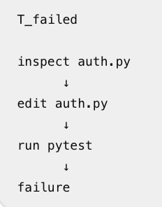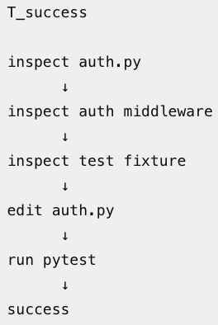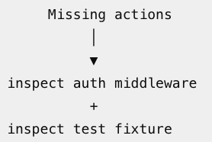

Research grounding: Experience Memory Graph (EMG) is the closest direct inspiration as it uses failed and successful action-decision graphs and derives graph-edit paths for error correction. ReAct provides the reasoning-and-acting trajectory structure, while trial-and-error trajectory work provides a related experience-optimization perspective.

B. Pi Agent Subsystem Integration

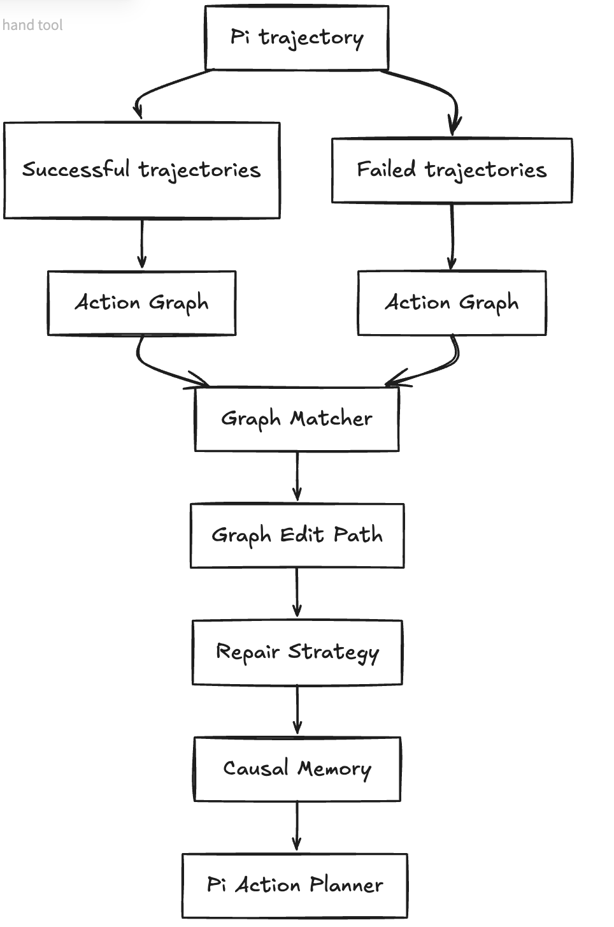

• afterToolCall: turn tool calls, observations, results, and errors into trajectory nodes and edges.
• Task-end consolidation: label completed trajectories as successful or failed and persist their action graphs.
• Cross-trajectory retrieval: when a new task fails, retrieve structurally similar successful trajectories.
• Graph matching: identify missing, incorrect, or reordered actions that distinguish the failed path from successful paths.
• beforeToolCall: inject the derived repair strategy before the next tool call.

Impact Over the Baseline
- Multi-Step Complex Recovery Workflows: While the baseline can only provide a single-line mitigation
string, EMG natively encodes multi-action recovery plans
- Elimination of Trial-and-Error Wandering: Backed by empirical evidence from Wang et al. (2026), EMG
drops the multi-turn exploratory reflection tax to exactly 1 corrective turn.

D. Research Papers References
- Experience Memory Graph: One-Shot Error Correction for Agents - Wang, Fang, Liu, Liang & Zheng, 2026
- Trial and Error: Exploration-Based Trajectory Optimization of LLM Agents — Song et al., 2024
- ReAct: Synergizing Reasoning and Acting in Language Models — Yao et al., 2023

Note - The architectures have been identified, but the final implementation scope will depend on the time required to understand the codebase and implement each approach. Therefore, it may not be feasible to implement all the proposed architectures within the four-week timeframe. However, at least one architecture for episodic memory and one for causal memory will definitely be implemented and evaluated during the four weeks.

